
LAB REPORT
Department of
INFORMATION AND COMMUNICATION ENGINEERING
PABNA UNIVERSITY OF SCIENCE AND TECHNOLOGY

Submitted To :
Dr. Md. Imran Hossain
Associate Professor
Dept. of Information and Communication Engineering

Submitted By :
Md.Sabbir Hossain
Roll : 220603
Session : 2021-22
Dept. of Information and Communication Engineering

ICE-2204
Signals and systems Sessional

Submission Date : 03-03-2025

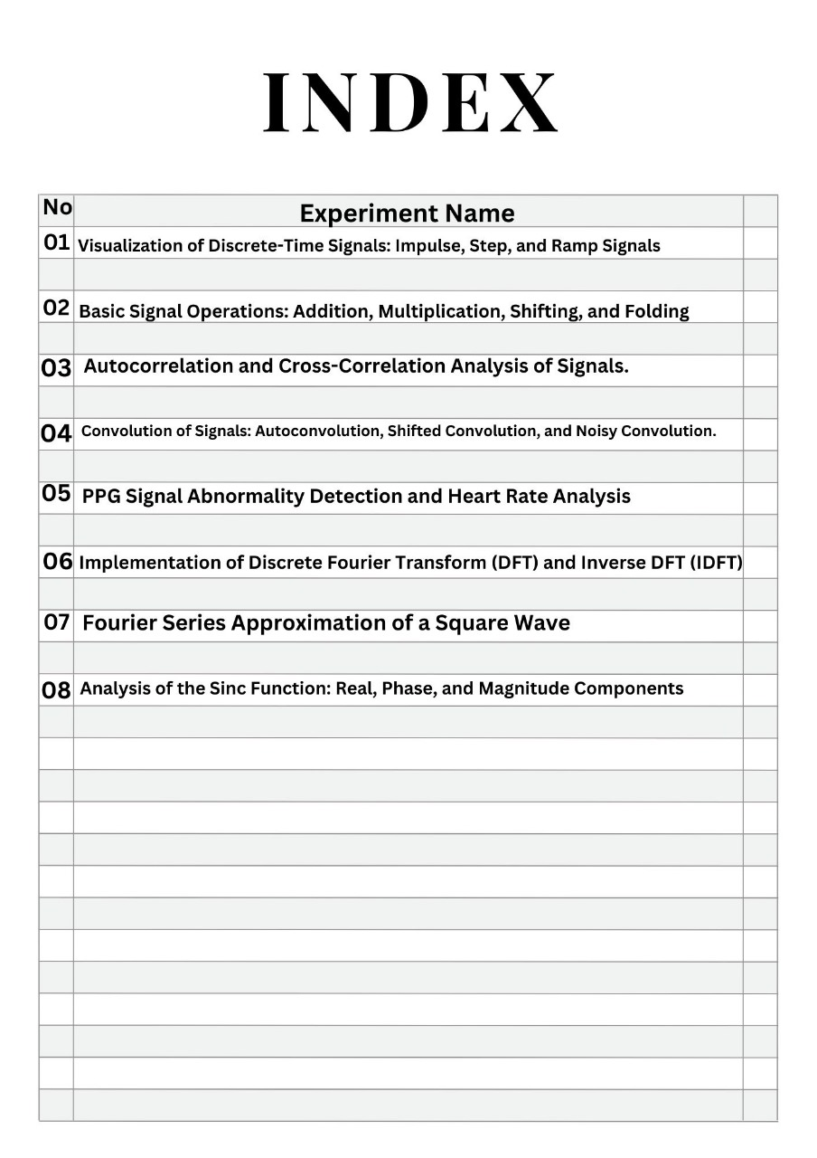
Signals And Systems Lab Report
Experiment No-1:
Tittle:Visualization of Discrete-Time Signals: (Impulse,Step,and Ramp Signals )

Theory:
• Impulse Signal (δ[n]): A discrete-time signal that is 1 at n = 0 and 0 elsewhere.
δ[n]={1if n=00if n≠0\delta[n] = \begin{cases} 1 & \text{if } n = 0 \\ 0 & \text{if } n \neq 0 \end{cases}δ[n]={10​if n=0if n=0​
• Step Signal (u[n]): A signal that is 0 for n < 0 and 1 for n ≥ 0.
u[n]={0if n<01if n≥0u[n] = \begin{cases} 0 & \text{if } n < 0 \\ 1 & \text{if } n \geq 0 \end{cases}u[n]={01​if n<0if n≥0​
• Ramp Signal (r[n]): A signal that increases linearly with n for n ≥ 0 and is 0 for n < 0.
r[n]={nif n≥00if n<0r[n] = \begin{cases} n & \text{if } n \geq 0 \\ 0 & \text{if } n < 0 \end{cases}r[n]={n0​if n≥0if n<0​
Objectives:
The goal of this experiment is to generate and analyze three fundamental discrete-time signals: Impulse, Step, and Ramp signals, and visualize their behavior.

Code:
import numpy as np
import matplotlib.pyplot as plt

# Define the range
n = np.arange(-10, 11)

def impulse_signal(n):
return np.where(n == 0, 1, 0)

def step_signal(n):
return np.where(n >= 0, 1, 0)

def ramp_signal(n):
return np.where(n >= 0, n, 0)

# Generate signals
impulse = impulse_signal(n)
step = step_signal(n)
ramp = ramp_signal(n)

# Plot signals
plt.figure(figsize=(12, 4))

plt.subplot(1, 3, 1)
plt.stem(n, impulse)
plt.title("Impulse Signal")
plt.xlabel("n")
plt.ylabel("Amplitude")
plt.grid()

plt.subplot(1, 3, 2)
plt.stem(n, step)
plt.title("Step Signal")
plt.xlabel("n")
plt.ylabel("Amplitude")
plt.grid()
plt.subplot(1, 3, 3)
plt.stem(n, ramp)
plt.title("Ramp Signal")
plt.xlabel("n")
plt.ylabel("Amplitude")
plt.grid()
plt.tight_layout()
plt.show()

Input:

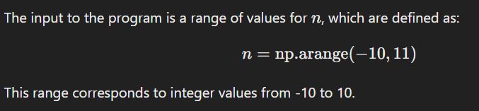

Output :
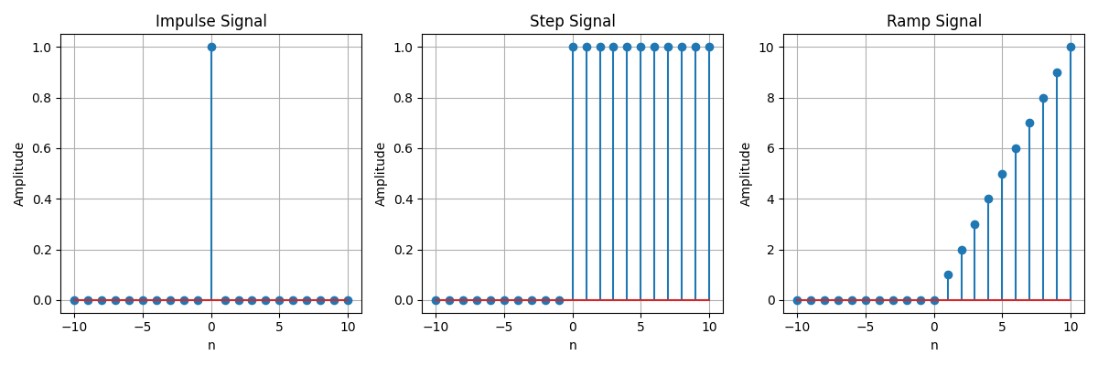

Purpose:
The purpose of this lab is to:
- Understand the properties and definitions of impulse, step, and ramp signals.
- Use Python to generate these signals over a range of nnn values.
- Visualize the signals using plots to analyze their behaviors.

Experiment No-02:
Tittle: Signal Operations: Addition, Multiplication, Scaling, Shifting, and Folding

Theory:
Signal processing involves manipulating signals to modify or enhance them. Common operations include:
- Addition: Combining two signals element-wise.
- Multiplication: Element-wise product of two signals.
- Scaling: Multiplying a signal by a constant to change its amplitude.
- Shifting: Translating a signal along the time axis.
- Folding: Reversing the signal with respect to time.
These operations are essential in fields like communications, audio processing, and control systems.

Objectives:
• Learn basic signal operations (addition, multiplication, scaling, shifting, folding).
• Visualize the effects of these operations on signals.
• Understand real-world applications of these operations in signal processing.
• Practice using Python for signal manipulation and visualization.

Code:
import numpy as np
import matplotlib.pyplot as plt
def signal_addition(x1, x2):
return x1 + x2

def signal_multiplication(x1, x2):
return x1 * x2

def signal_scaling(x, alpha):
return alpha * x

def signal_shifting(n, shift):
return n + shift

def signal_folding(x):
return np.flip(x)

n = np.array([-2, -1, 0, 1, 2])
x1 = np.array([1, 2, 3, 4, 5])
x2 = np.array([5, 4, 3, 2, 1])

added_signal = signal_addition(x1, x2)
multiplied_signal = signal_multiplication(x1, x2)
scaled_signal = signal_scaling(x1, 2)
shifted_signal1 = signal_shifting(n, -2)
shifted_signal2 = signal_shifting(n, 2)
folded_signal = signal_folding(x1)

plt.figure(figsize=(12, 10))

plt.subplot(4, 2, 1)
plt.stem(n, x1)
plt.xlabel("Time")
plt.ylabel("Amplitude")
plt.title("Original Signal x1")
plt.grid()

plt.subplot(4, 2, 2)
plt.stem(n, x2)
plt.xlabel("Time ")
plt.ylabel("Amplitude")
plt.title("Original Signal x2")
plt.grid()

plt.subplot(4, 2, 3)
plt.stem(n, added_signal)
plt.xlabel("Time")
plt.ylabel("Amplitude")
plt.title("Signal Addition")
plt.grid()

plt.subplot(4, 2, 4)
plt.stem(n, multiplied_signal)
plt.xlabel("Time")
plt.ylabel("Amplitude")
plt.title("Signal Multiplication")
plt.grid()

plt.subplot(4, 2, 5)
plt.stem(n, scaled_signal)
plt.xlabel("Time")
plt.ylabel("Amplitude")
plt.title("Scaled Signal (x1 * 2)")
plt.grid()

plt.subplot(4, 2, 6)
plt.stem(shifted_signal1, x1)
plt.xlabel("Time")
plt.ylabel("Amplitude")
plt.title("Shifted Signal (Shift = -2)")
plt.grid()

plt.subplot(4, 2, 7)
plt.stem(shifted_signal2, x1)
plt.xlabel("Time")
plt.ylabel("Amplitude")
plt.title("Shifted Signal (Shift = +2)")
plt.grid()

plt.subplot(4, 2, 8)
plt.stem(n, folded_signal)
plt.xlabel("Time")
plt.ylabel("Amplitude")
plt.title("Folded Signal (x1)")
plt.grid()

plt.tight_layout()
plt.show()
Input:

Output :

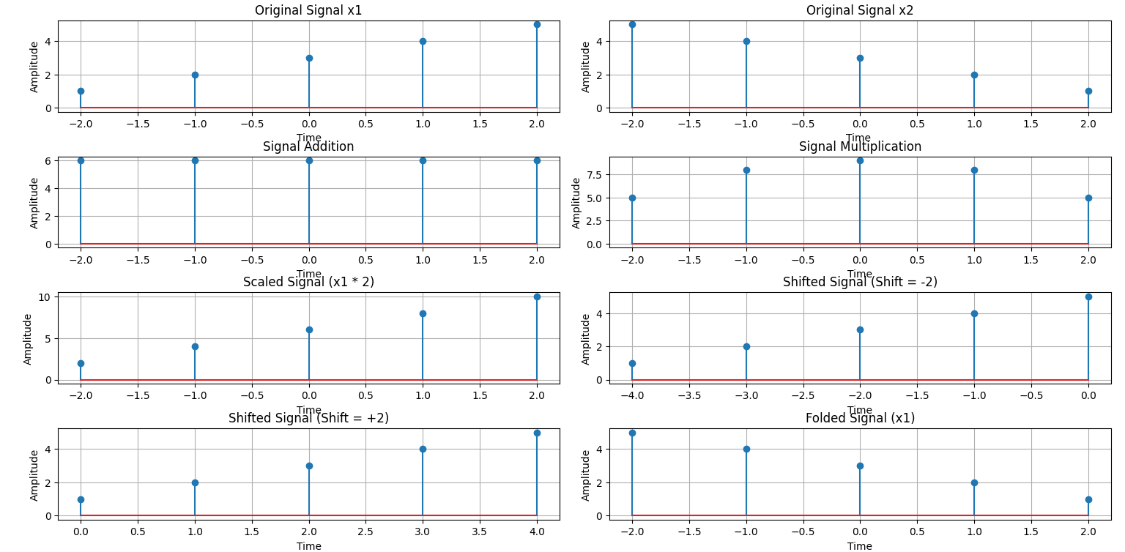

Purpose:
The purpose of the program is to demonstrate common signal operations, including signal addition, multiplication, scaling, shifting, and folding, and visualize their effects on the input signals.

Experiment No-03:
Tittle: Autocorrelation and Cross-Correlation Analysis of Signals with Noise

Theory:
- Autocorrelation measures the similarity of a signal with itself over different time lags, helping to identify periodicity or patterns within the signal.
- Cross-correlation measures the similarity between two signals, helping to detect relationships and align signals in time.
These techniques are used in signal detection, noise reduction, and time delay estimation.

Objectives:
- Understand and compute autocorrelation and cross-correlation.
- Analyze signal periodicity and the relationship between signals.
- Visualize how correlation can help in real-world signal processing tasks.
- Learn to implement these methods using Python libraries.

Code:
import numpy as np
import matplotlib.pyplot as plt
from scipy.signal import correlate, correlation_lags
def compute_autocorrelation(signal):
auto_corr = correlate(signal, signal, mode='full', method='auto')
lags = correlation_lags(len(signal), len(signal), mode='full')
return auto_corr, lags
def compute_cross_correlation(signal1, signal2):
cross_corr = correlate(signal1, signal2, mode='full', method='auto')
lags = correlation_lags(len(signal1), len(signal2), mode='full')
return cross_corr, lags

fs = 1000 # Sampling frequency in Hz
t = np.linspace(0, 1, fs, endpoint=False) # Time vector
freq = 5 # Frequency of the sine wave

sin_signal = np.sin(2 * np.pi * freq * t)

auto_corr, lags_auto = compute_autocorrelation(sin_signal)
signal1 = sin_signal
signal2 = np.roll(signal1, 100)
cross_corr, lags_cross = compute_cross_correlation(signal1, signal2)
noise = np.random.normal(0, 0.5, fs)
noisy_signal = signal1 + noise
cross_corr_noise, lags_noise = compute_cross_correlation(signal1, noisy_signal)

plt.figure(figsize=(12, 12))

plt.subplot(3, 1, 1)
plt.plot(lags_auto, auto_corr)
plt.title("Autocorrelation of a Sinusoidal Signal")
plt.xlabel("Lag")
plt.ylabel("Autocorrelation")
plt.grid()

plt.subplot(3, 1, 2)
plt.plot(lags_cross, cross_corr)
plt.title("Cross-Correlation between Two Signals")
plt.xlabel("Lag")
plt.ylabel("Cross-Correlation")
plt.grid()

plt.subplot(3, 1, 3)
plt.plot(lags_noise, cross_corr_noise)
plt.title("Cross-Correlation with Noisy Signal")
plt.xlabel("Lag")
plt.ylabel("Cross-Correlation")
plt.grid()

plt.tight_layout()
plt.show()

Input:
The input consists of:
- A sinusoidal signal with a frequency of 5 Hz, sampled at 1000 Hz.
- A shifted version of the sinusoidal signal for cross-correlation.
- A noisy version of the sinusoidal signal (created by adding random noise).
Output:
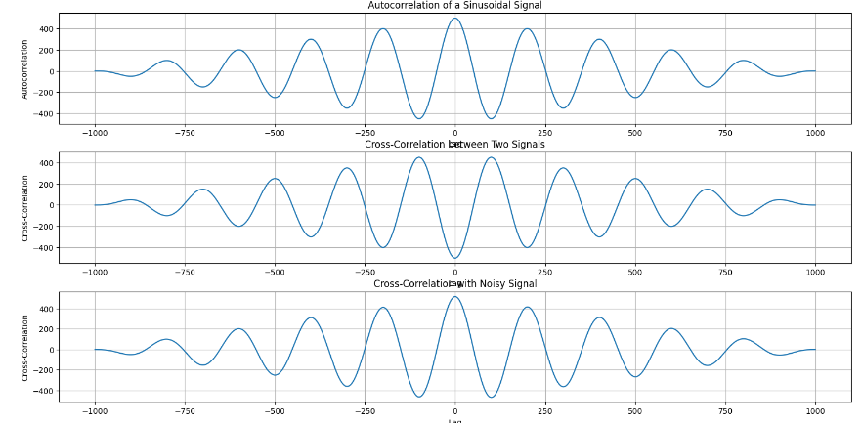

Purpose:
The purpose of this program is to compute and visualize:
- The autocorrelation of a sinusoidal signal.
- The cross-correlation between two signals (one being a shifted version of the other).
- The cross-correlation between a sinusoidal signal and a noisy signal, to observe how noise affects the correlation.

Experiment No: 04
Tittle: Convolution Analysis of Signals: Autoconvolution, Shifted Signals, and Noise Effects

Theory:
Convolution is a mathematical operation that combines two signals to produce a third, showing their overlap as a function of time shift. Key concepts include:
- Autoconvolution: Convolving a signal with itself to detect patterns and periodicity.
- Convolution with Shifted Signals: Analyzing the similarity between a signal and its shifted version.
- Convolution with Noisy Signals: Studying the effect of noise on a signal through convolution.

Objectives:
• Understand and visualize autoconvolution and its properties.
• Analyze convolution with shifted signals to measure time shifts and similarity.
• Investigate the effect of noise in signal processing through convolution.
• Practice implementing convolution using Python and relevant libraries.

Code:

import numpy as np
import matplotlib.pyplot as plt
from scipy.signal import convolve
def compute_convolution(signal1, signal2):
conv_result = convolve(signal1, signal2, mode='full', method='auto')
return conv_result
fs = 1000 # Sampling frequency in Hz
t = np.linspace(0, 1, fs, endpoint=False) # Time vector
freq = 5 # Frequency of the sine wave
sin_signal = np.sin(2 * np.pi * freq * t)
conv_auto = compute_convolution(sin_signal, sin_signal)
signal1 = sin_signal
signal2 = np.roll(signal1, 100)
conv_shifted = compute_convolution(signal1, signal2)
noise = np.random.normal(0, 0.5, fs)
noisy_signal = signal1 + noise
conv_noisy = compute_convolution(signal1, noisy_signal)

plt.figure(figsize=(12, 12))

plt.subplot(3, 1, 1)
plt.plot(conv_auto)
plt.title("Autoconvolution of a Sinusoidal Signal")
plt.xlabel("Samples")
plt.ylabel("Convolution Output")
plt.grid()

plt.subplot(3, 1, 2)
plt.plot(conv_shifted)
plt.title("Convolution between Signal and Shifted Version")
plt.xlabel("Samples")
plt.ylabel("Convolution Output")
plt.grid()

plt.subplot(3, 1, 3)
plt.plot(conv_noisy)
plt.title("Convolution with Noisy Signal")
plt.xlabel("Samples")
plt.ylabel("Convolution Output")
plt.grid()

plt.tight_layout()
plt.show()

Input:
The input consists of:
- A sinusoidal signal with a frequency of 5 Hz, sampled at 1000 Hz.
- A shifted version of the sinusoidal signal for convolution.
- A noisy version of the sinusoidal signal (created by adding random noise)

Output :
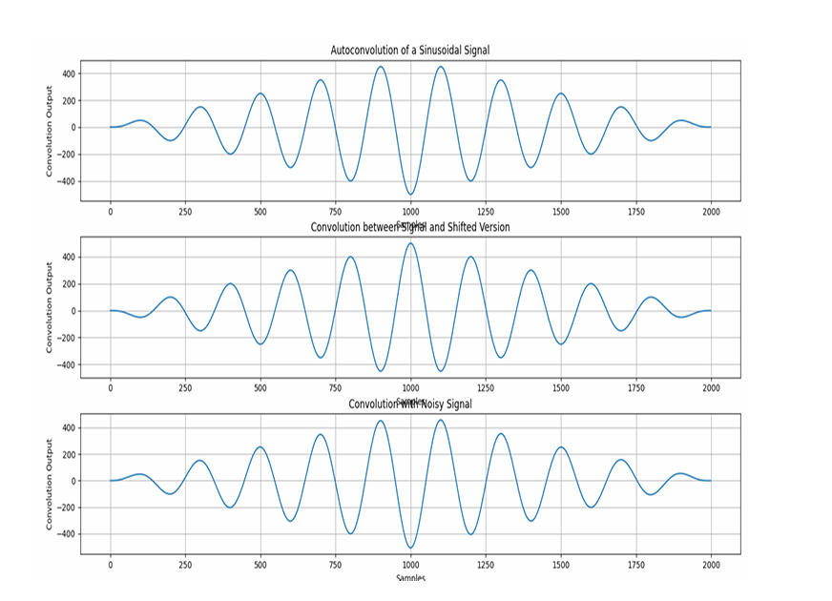

Purpose:
The purpose of this program is to compute and visualize:
- The autoconvolution of a sinusoidal signal.
- The convolution between a sinusoidal signal and its shifted version.
- The convolution between a sinusoidal signal and a noisy signal, to observe the effect of noise on the convolution output.

Experiment No- 05
Tittle - Heart Rate Estimation from PPG Signal Using Bandpass Filtering and Peak Detection

Theory:
This code processes a PPG signal to estimate heart rate by:
- Bandpass Filtering: Removes noise and retains frequencies relevant to the heart rate (0.5 Hz to 5 Hz).
- Peak Detection: Identifies peaks in the signal corresponding to heartbeats.
- Heart Rate Estimation: Calculates the heart rate by averaging the time intervals between peaks (R-R intervals).
- Normalization: Scales the signal for easier peak detection.

Objectives:
• Apply bandpass filtering to clean the PPG signal.
• Detect peaks in the filtered signal.
• Estimate heart rate by analyzing the R-R intervals.
• Visualize the signal processing stages.
• Understand how signal processing techniques are used in health monitoring for heart rate estimation.

Code:

import numpy as np
import scipy.signal as signal
import matplotlib.pyplot as plt
def bandpass_filter(data, fs=100):
b, a = signal.butter(4, [0.5 / (0.5 * fs), 5.0 / (0.5 * fs)], btype='band')
return signal.filtfilt(b, a, data)
def detect_peaks(signal_data):
return signal.find_peaks(signal_data, distance=50)[0]
def extract_heart_rate(peaks, fs=100):
if len(peaks) < 2:
return 0
rr_intervals = np.diff(peaks) / fs
return 60 / np.mean(rr_intervals)
# Generate synthetic PPG signal
fs = 100
t = np.linspace(0, 10, fs * 10)
sine_signal = np.sin(2 * np.pi * 1.2 * t)
noise_signal = 0.1 * np.random.normal(0, 1, len(t))
ppg_signal = sine_signal + noise_signal

# Process PPG signal
filtered_signal = bandpass_filter(ppg_signal, fs)
normalized_signal = (filtered_signal - np.min(filtered_signal)) / (np.max(filtered_signal) -
np.min(filtered_signal))
peaks = detect_peaks(normalized_signal)
heart_rate = extract_heart_rate(peaks, fs)

# Print results
print("Filtered Signal (first 10 values):", filtered_signal[:10])
print("Detected Peaks (first 10 indices):", peaks[:10])
print(f"Estimated Heart Rate: {heart_rate:.2f} BPM")

# Plot results
plt.figure(figsize=(12, 9))
plt.subplot(3, 2, 1)
plt.plot(t, sine_signal, label='Raw Sine Signal')
plt.xlabel("Time")
plt.ylabel("Amplitude")
plt.legend()

plt.subplot(3, 2, 2)
plt.plot(t, noise_signal, label='Raw Noise Signal')
plt.xlabel("Time")
plt.ylabel("Amplitude")
plt.legend()

plt.subplot(3, 2, 3)
plt.plot(t, ppg_signal, label='Raw PPG Signal')
plt.xlabel("Time")
plt.ylabel("Amplitude")
plt.legend()

plt.subplot(3, 2, 4)
plt.plot(t, filtered_signal, label='Filtered PPG Signal')
plt.xlabel("Time")
plt.ylabel("Amplitude")
plt.legend()
plt.subplot(3, 2, 5)
plt.plot(t, normalized_signal, label='Normalized PPG Signal')
plt.xlabel("Time")
plt.ylabel("Amplitude")
plt.legend()
plt.subplot(3, 2, 6)
plt.plot(t, normalized_signal,label=f'PPG with Detected Peaks')
plt.plot(t[peaks], normalized_signal[peaks],'ro', label='Detected Peaks')
plt.xlabel("Time")
plt.ylabel("Amplitude")
plt.legend()
plt.tight_layout()
plt.show()

Input:
The input consists of:
- A synthetic PPG signal, created by adding a sine wave of 1.2 Hz frequency and Gaussian noise.
- A sampling frequency fs=100fs = 100fs=100 Hz.
Output:
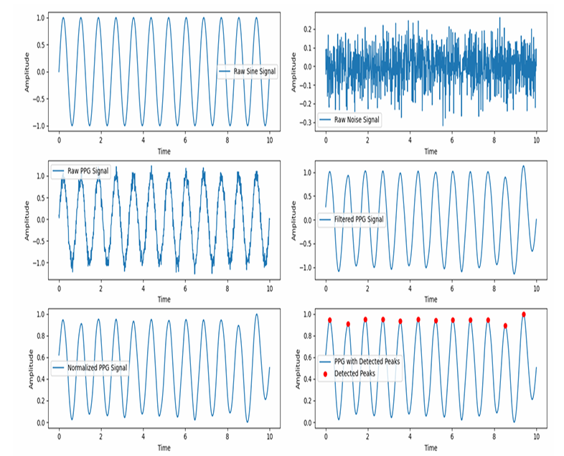

Purpose: The purpose of this program is to:
- Filter the PPG signal using a bandpass filter.
- Normalize the filtered signal for peak detection.
- Detect peaks in the PPG signal.
- Estimate heart rate based on the detected peaks by calculating the RR intervals and computing the average heart rate in beats per minute (BPM).
Experiment No: 06
Tittle: Discrete Fourier Transform (DFT) and Inverse DFT (IDFT) of a Signal

Theory:
- DFT (Discrete Fourier Transform) converts a time-domain signal into its frequency components, revealing the signal's frequency content.
- IDFT (Inverse Discrete Fourier Transform) reconstructs the original time-domain signal from its frequency components.
These transforms are essential in signal processing for tasks like spectrum analysis and signal reconstruction.

Objectives:
• Compute the DFT of a signal and analyze its frequency components.
• Reconstruct the signal using the IDFT.
• Visualize the original signal, its frequency spectrum, and the reconstructed signal.

Code:
mport numpy as np
import matplotlib.pyplot as plt
# Input sequence and N
x = [1,1,1,1]
N= 4
x = np.pad(x, (0, N - len(x)), mode='constant')
# DFT computation
X = np.fft.fft(x, N)
# IDFT computation (Inverse DFT)
x_reconstructed = np.fft.ifft(X)

# Print the DFT and IDFT values
print("DFT values:", X)
print("Reconstructed IDFT values:", x_reconstructed.real)

# Plot the input signal
plt.figure(figsize=(10, 6))

plt.subplot(3, 1, 1)
plt.stem(range(len(x)), x)
plt.title('Input Signal x(n)')
plt.xlabel('n')
plt.ylabel('x(n)')
plt.grid()

# Plot the magnitude of DFT
plt.subplot(3, 1, 2)
plt.stem(range(N), np.abs(X))
plt.title('DFT Magnitude |X(k)|')
plt.xlabel('k')
plt.ylabel('|X(k)|')
plt.grid()

# Plot the IDFT signal
plt.subplot(3, 1, 3)
plt.stem(range(N), x_reconstructed.real)
plt.title('Reconstructed Signal x(n) from IDFT')
plt.xlabel('n')
plt.ylabel('x(n)')
plt.grid()

plt.tight_layout()
plt.show()

Input:
The input consists of:
- A sequence x=[1,1,1,1]
- The length N=4 for the DFT computation.

Output:
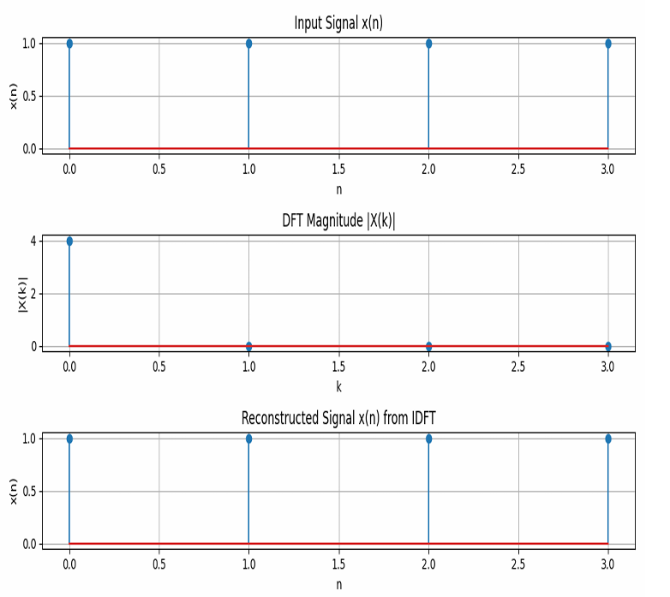

Purpose:
The purpose of this program is to:
- Compute the Discrete Fourier Transform (DFT) of the input signal.
- Reconstruct the original signal using the Inverse Discrete Fourier Transform (IDFT).
- Visualize the input signal, the magnitude of the DFT, and the reconstructed signal.

Experiment No: 07
Tittle : Fourier Series Approximation of a Square Wave

Theory:
The Fourier Series is a mathematical tool used to express a periodic function as a sum of sine and cosine functions. It helps to approximate complex periodic signals using simpler sinusoidal components.
- Square Wave:
  - A square wave is a periodic waveform that alternates between two levels, typically +1 and -1. It is a non-sinusoidal waveform, often used in digital signals and communications.
- Fourier Series Approximation:
  - The Fourier series allows us to approximate any periodic function (such as a square wave) as a sum of sinusoidal functions (sines and cosines). For a square wave, the Fourier series consists only of odd harmonics (sine terms with odd multiples of the fundamental frequency).
  - As the number of terms in the Fourier series increases, the approximation becomes closer to the original square wave, exhibiting sharp transitions between the levels.

Objectives:
• Understand Fourier Series:
- Learn how Fourier series decompose a periodic function into a sum of sinusoidal components.
• Approximate Square Wave:
- Use Fourier series to approximate a square wave using a specified number of terms (odd harmonics).
• Visualize Approximation:
- Plot the original square wave and its Fourier series approximations with different numbers of terms to observe how the approximation improves as more terms are added.
• Explore the Convergence of Fourier Series:
- Study how increasing the number of terms in the Fourier series leads to a better approximation of the square wave, especially in terms of the sharp transitions.

Code:
import numpy as np
import matplotlib.pyplot as plt
def fourier_series(x, terms):
if terms < 1:
raise ValueError("Number of terms must be at least 1")
result = x - x
for n in range(1, terms + 1, 2):
result += (4 / (np.pi * n)) * np.sin(n * x)
return result

# Define the original square wave function
def square_wave(x):
return np.where(np.sin(x) >= 0, 1, -1)

# Generate x values
t = np.linspace(-np.pi, np.pi, 400)

# Plot different approximations
plt.figure(figsize=(8, 6))

# Plot the original square wave
plt.plot(t, square_wave(t), label='Original Square Wave', linestyle='--', color='black')

for terms in [1, 3, 5, 9]:
plt.plot(t, fourier_series(t, terms), label=f'{terms} terms')

plt.axhline(0, color='black', linewidth=0.5, linestyle='--')
plt.title('Fourier Series Approximation of a Square Wave')
plt.xlabel('Time')
plt.ylabel('Amplitude')
plt.legend()
plt.grid()
plt.show()

Input:
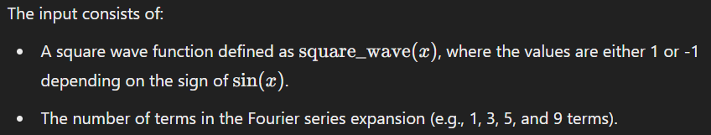

Output:
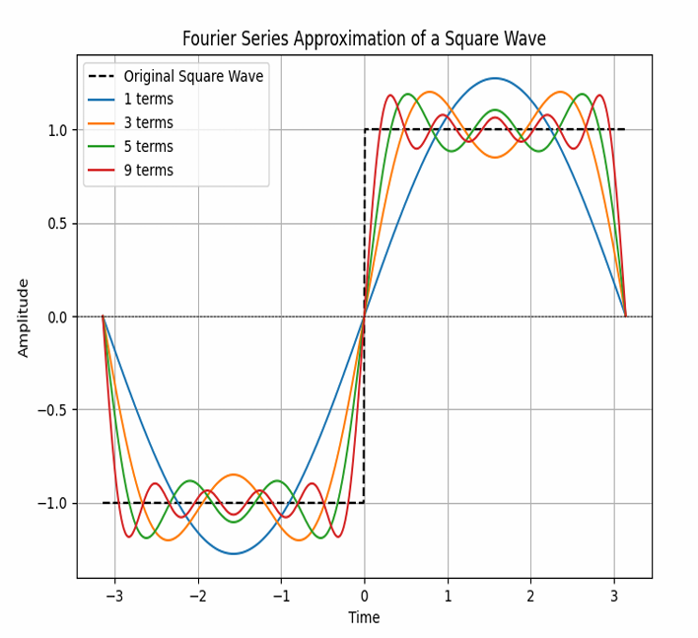

Purpose:
The purpose of this program is to:
- Approximate a square wave using a Fourier series with different numbers of terms.
- Visualize the approximation of the square wave for different numbers of terms in the Fourier series and compare it to the original square wave.

Experiment No: 08
Tittle: visualizing the real, phase, and magnitude components of the sinc function.

Theory:
e sinc function is defined as:
sinc(x)=sin⁡(πx)πx\text{sinc}(x) = \frac{\sin(\pi x)}{\pi x}sinc(x)=πxsin(πx)​
However, in this case, the function is scaled as sinc(4t)\text{sinc}(4t)sinc(4t), which is a normalized version of the sinc function.
- Real Part: The real part of a complex signal is the actual value of the signal at any given time.
- Phase Part: The phase represents the shift of the signal in time. It can be obtained using the angle of the signal, angle(x)\text{angle}(x)angle(x), which gives the phase of the complex values.
- Magnitude Part: The magnitude represents the absolute value of the signal at any point in time. It provides information about the amplitude of the signal.

Objectives:
• Plot the Real Part of the sinc function to show its time-domain behavior.
• Plot the Phase Part to visualize how the phase varies across time (though, for real signals, this may remain constant or be zero).
• Plot the Magnitude Part to observe the amplitude of the sinc function and its decay with time.
• Understand the sinc function's properties and how it relates to signal processing and frequency response.

Code:
import numpy as np
import matplotlib.pyplot as plt
t = np.arange(-2, 2.01, 0.01)
x = 4 * np.sinc(4 * t)
# Plot real part
plt.figure(figsize=(10, 6))
plt.subplot(3, 1, 1)
plt.plot(t, x)
plt.xlabel('Time')
plt.ylabel('Amplitude')
plt.title('Real Part')
plt.grid()

# Plot phase part
plt.subplot(3, 1, 2)
plt.plot(t, np.angle(x))
plt.xlabel('Time')
plt.ylabel('Amplitude')
plt.title('Phase Part')
plt.grid()

# Plot magnitude part
plt.subplot(3, 1, 3)
plt.plot(t, np.abs(x))
plt.ylabel('Amplitude')
plt.title('Magnitude Part')
plt.grid()

plt.tight_layout()
plt.show()

Input:
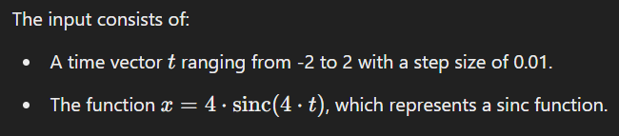

Output:
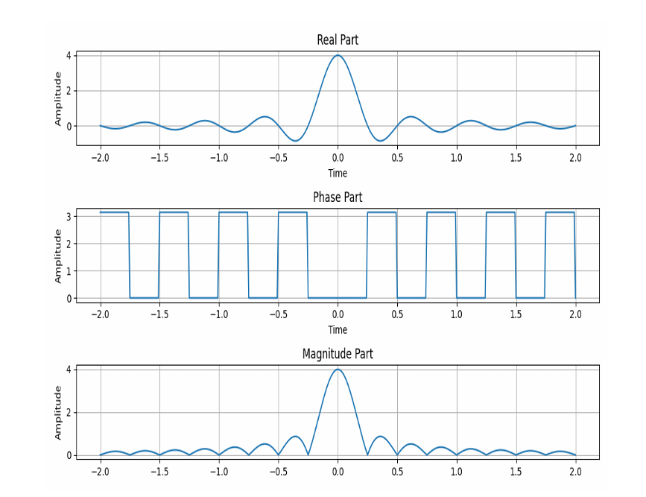
Purpose:
The purpose of this program is to:
- Visualize the real part, phase part, and magnitude part of the sinc function xxx.
- Plot these components to understand their characteristics over the given time range.

